

**Canteen Ordering System - Unilever**

**CBAP Certification Project 1**

Submitted to

**Simplilearn Project for CBAP**

Submission by**:**

**Aakash Kumar**

Date of Submission:

Table of Contents

Introduction 3

Business Analysis Core Concept Model (BACCM) 4

Requirements Classification Schema (RCS) 4

Task 1: Stakeholders 5

Identify Key Stakeholders 5

RACI Matrix 6

Onion Diagram 7

Task 2: Identify the problem statement in this system 8

Task 3: Advantages and Objectives 10

Task 4: Process Map (using flowcharts) 11

AS-IS (Activity) Diagram 11

Future State (Swimlane) Diagram 12

Task 5: The Scope of the Canteen Ordering System 13

(Context Diagram) 13

(UML Diagram) 14

Task 6: Main feathers that need to be developed 15

Task 7: The In-scope and Out-of-scope items for this software 15

Task 8: An Activity diagram for the system 16

Task 9: ER Diagram for the system 17

Task 10: The Business requirements, both the Functional and Non-Functional 17

Functional requirements : 17

Non-Functional requirements : 18

Task 11: Wireframes – Homepage, Food Menu and Feedback Page Screen 19

# **Introduction**

Unilever is a British-Dutch MNC FMCG company, headquartered in London, England. Unilever is one of the oldest FMCG companies, and its products are available in around 190 countries. In its UK offices, Unilever had around 1500 employees which were spread across twelve floors. They had two canteens to cater to these 1500 employees. Each canteen could seat around 150 employees at a time. Most employees would prefer to take their lunch between 12 noon to 1 pm. This led to a huge rush in the canteen during lunch hours resulting in employees wasting a lot of time waiting for tables to be vacant. Management calculated that it took around 60 minutes for employees to go and come back from lunch. Almost 30-35 minutes were wasted waiting in a queue to collect their food and get a table to sit and eat. However, the time spent eating was barely 10-15 minutes. The remaining 10 minutes were spent reaching and coming back from the canteen using the elevators. Employees don’t always get the choice of food they want because the canteen runs out of certain items. The canteen wastes a significant quantity of food by throwing away what is not purchased. Many employees have requested a system that would permit a canteen user to order meals online, to be delivered to their work location at a specified time and date.

### Business Analysis Core Concept Model (BACCM)

|  |  |
| --- | --- |
| Need | The need is to initiate an online canteen ordering system which can reduce food wastage, operating costs, manpower and increase employee’s work time. |
| Change | By automating the current canteen system, a meal ordering website will be created. |
| Solution | The solution is to create an online canteen ordering system in Java so that employers can order their meals on their workstations. |
| Context | The context is leading to a change where the company has to cater to 1500 employees during lunchtime (12-1 pm). This causes a huge rush in the canteen and leads to a waste of time for employee’s seating. |
| Value | The value add with the new system are:   * Saves manpower and employees’ time to increase efficiency. * Low operating costs, less food waste, and * no lunchtime rush in the canteen. |
| Stakeholder | External Stakeholders:   * Supplier * Project Manager * Implementation SME * Operational IT Team * Testers   Internal Stakeholders:   * Inventory Manager * Chef * Canteen Manager * Employees * Meal Deliverer * Payroll Team   **Business Analyst** – Liaison (Bridging a gap b/w external and Internal stakeholder or who is free from any business and technical biases). |

### Requirements Classification Schema (RCS)

* **Business requirements**: To automate the canteen ordering system by developing an online food ordering portal for the company that can increase efficiency and save time and manpower.
* Reduce canteen food wastage by a minimum of 30% within 6 months following the first release.
* Reduce canteen operating costs by 15% within 12 months, following initial release.
* Increase average effective work time by 30 minutes per employee per day, within 3 months.
* By making the ordering process automated and by delivering the food to the user’s workstation, the canteen will be able to operate with lesser manpower.
* **Stakeholder requirements**: The key stakeholders are employees, the canteen manager, the meal deliverer and the payroll manager.
* Employees: The users will be able to log in and order food online through the system. The food will be delivered at their workstations and the amount of the meal will be deducted from the monthly salary.
* Canteen Manager: The canteen manager should be able to view the orders, take the inventory of all the orders and get them cooked by the chef. The manager should be able to request a delivery to the employee’s workstation.
* Meal delivery person: After successful delivery of the meal the delivery boy should be able to close the online customer order.
* Payroll team: The team needs to calculate the total number of dishes ordered by each employee and shall deduct money from the employee’s salary.
* **Solution requirements:**
* Functional requirements: An online web portal or mobile application is required to be developed to automate the canteen food delivery system. The system will be created and maintained on Java as it requires very little maintenance to be done on the code.
* Non- Functional requirements: This Canteen system order is required to support a volume of 1500 employees at one time so that the webpage should be light and render fast. The system should be scalable, self-explanatory and user-friendly.
* **Transition requirements:** The users of the system should be trained enough to use it efficiently. A helpdesk team can be arranged to assist in case of any errors or problems faced by the users while using the system.

# **Task 1: Stakeholders**

### Identify Key Stakeholders

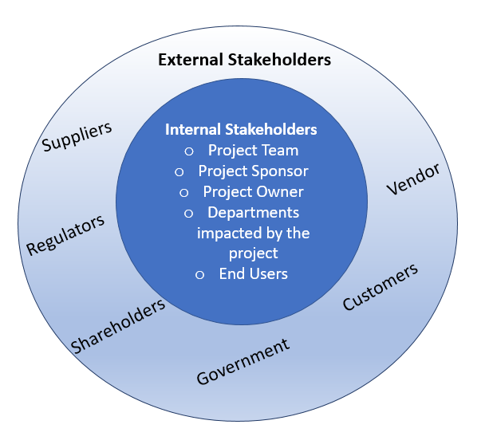

RACI Matrix: is used for the identification of the responsibility of each stakeholder involved in the process

* **Responsible (R):** The personas who will be performing the work on the task.
* **Accountable (A):** The person who is ultimately held accountable for the successful completion of the task and is the decision maker.
* **Consulted (C):** The Stakeholder or group of stakeholders who will be asked to provide an option opinion or information.
* **Informed (I):** A Stakeholder or group of stakeholders that is kept up to date on the task and notified of its outcome.



### Onion Diagram

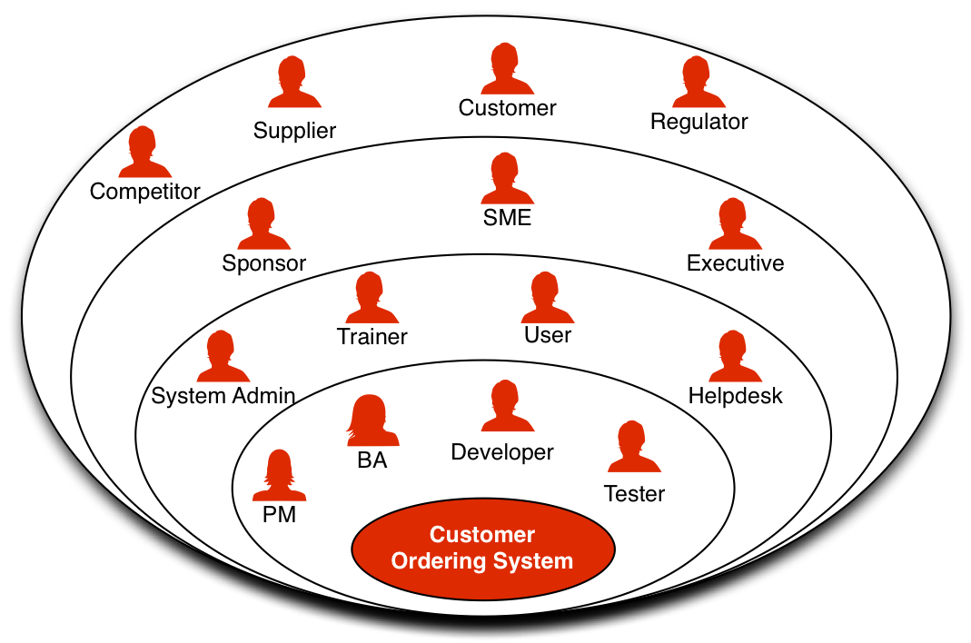

# **Task 2: Identify the problem statement in this system**

The Company provides food service via 2 canteens that serve all 1500 employees. Employees prefer to have lunch between 12 to 1 PM. Each canteen seats around 150 employees at a time. This led to a huge rush in the canteen during lunch hours resulting in employees wasting a lot of time waiting for tables to be vacant. Here, employees spend 10 minutes travelling, doing back and forth where 15+ minutes ordering the food and another 15-20 minutes waiting for a seat. Moreover, the canteen has also been reporting a 25% wastage in food items due to nonpurchase each month.

Now, to alleviate overcrowding of the canteens, reduce costs and improve service to employees, management has embarked on a project on an automated system that will allow employees to order their lunch for eating at their work station. Furthermore, employees have complained many of their favourite food items were not available by the time their lunch hour arrived. An automated ordering system will track which foods that are most popular and help meet the higher demand.

The above problem scenario is represented by the **Fishbone** diagram below:

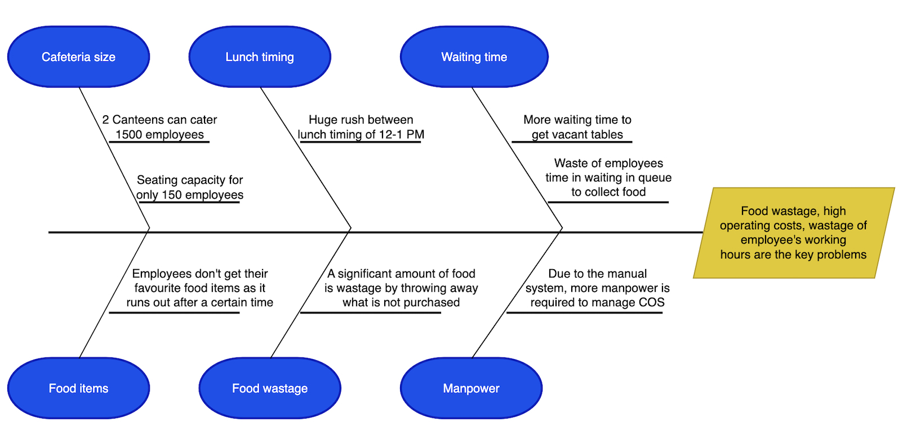

Fishbone Diagram

# **Task 3: Advantages and Objectives**

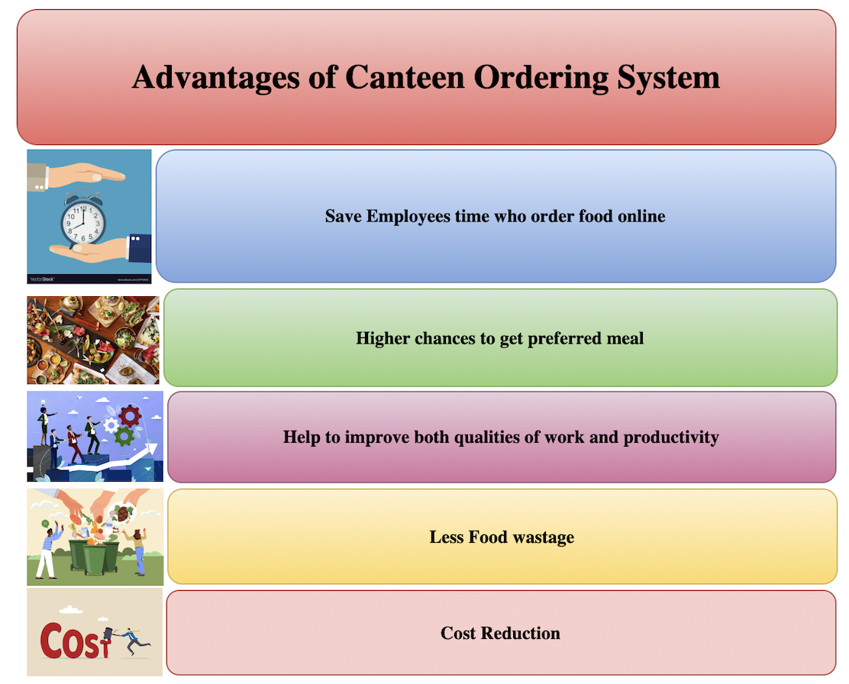

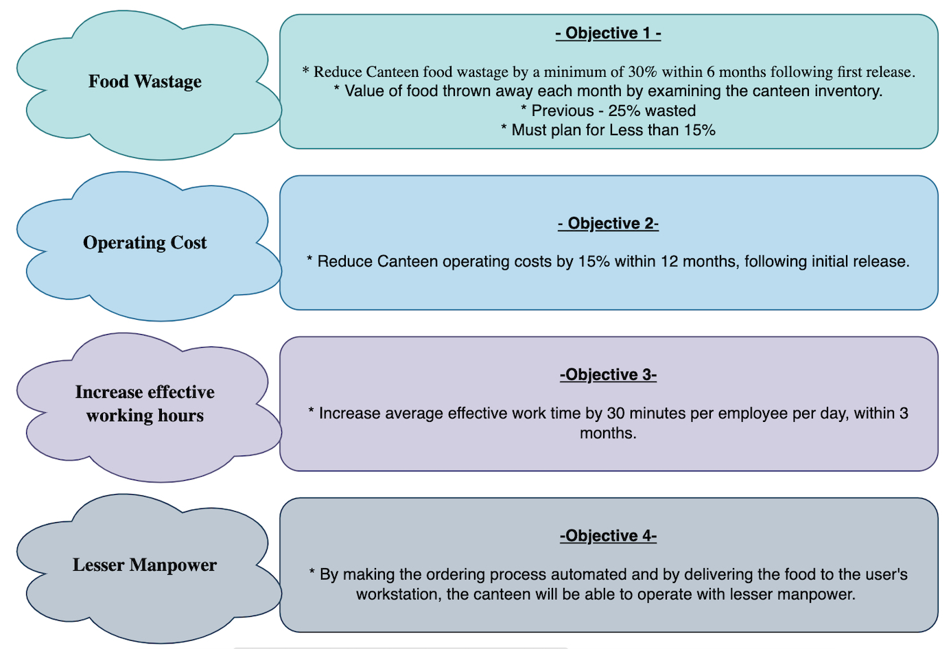

# **Task 4: Process Map (using flowcharts)**

### AS-IS (Activity) Diagram

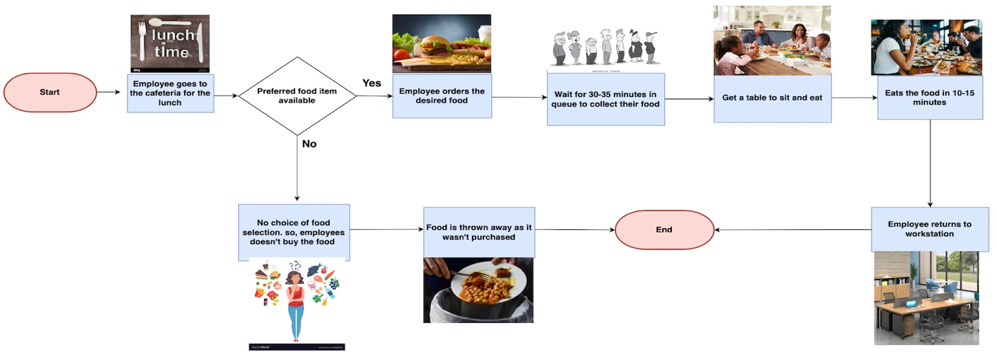

**AS-IS State**

### Future State (Swimlane) Diagram

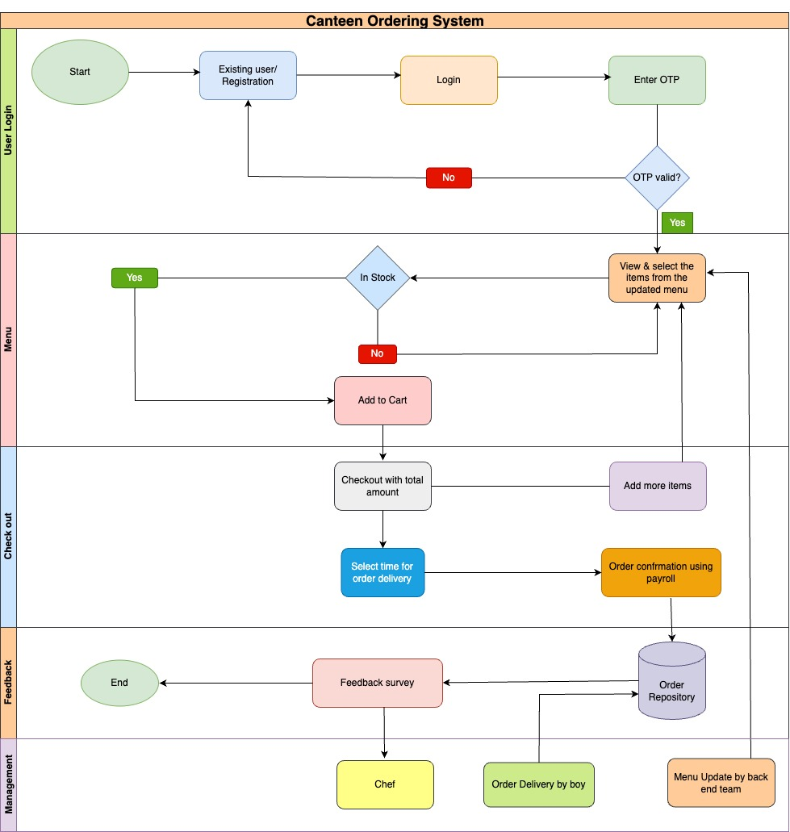

# **Task 5: The Scope of the Canteen Ordering System**

### (Context Diagram)

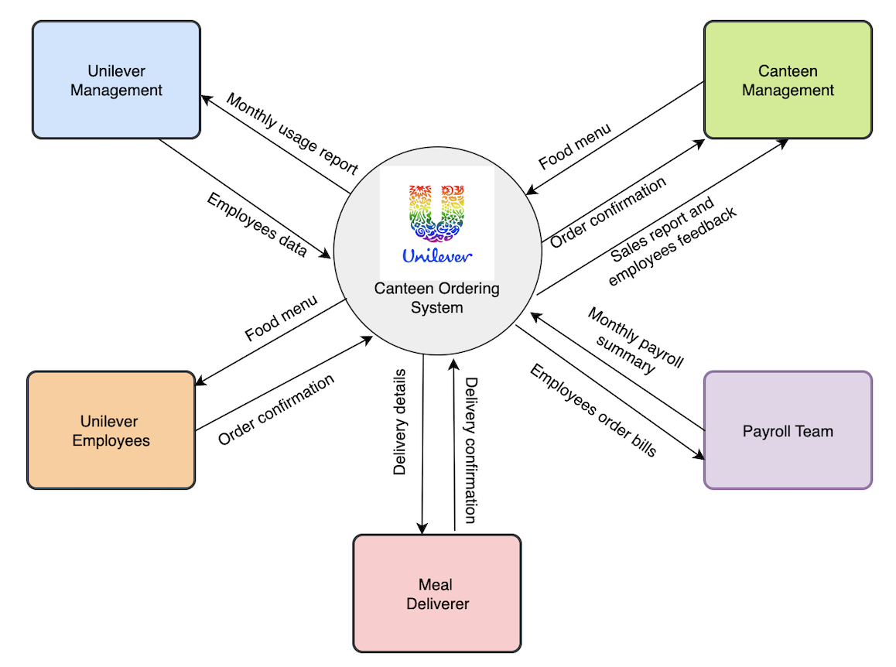

### (UML Diagram)

# 

# **Task 6: Main feathers that need to be developed**

1. The System's registration and login page for employees.
2. An updated meal menu with all the food items should be accessible to an employee when logging in successfully.
3. Order of food must not be issued after 11 am so that the cook has enough time to prepare lunch for all staff.
4. After adding the desired food items to the cart, employees may place an order for lunch and confirm it.
5. The staff member will not be able to amend or cancel the order when confirmation has been received.
6. After carefully checking all the orders, The canteen manager assigns them to the chef for preparation.
7. For the delivery of meals to an employee's workstation, a packed order will be given to the food delivery boy.
8. The food delivery boy will mark the order as closed once it has been delivered.
9. Employees will be asked to fill out the feedback form for their orders after the completion of an order.
10. The payment gateway will not be available so the payroll team deducts the bill amount from the employee's monthly salary.

# **Task 7: The In-scope and Out-of-scope items for this software**

**In-Scope requirements :**

* Employee registration/ Login screen
* Menu Page
* Meal ordering screen (No order will take after 11 am)
* Order confirmation screen
* Payment Summary
* Order status page
* Meal status details
* Close delivered order by meal delivery person
* Monthly payroll deduction
* Feedback form
* Sales report
* Canteen Management

**Out-of-scope requirements :**

* No employee outside Unilever is authorized to order food.
* Food Delivery is prohibited outside the office.
* No selection is possible for food items not available as part of the food inventory.
* The chef and meal delivery person pay details.

# **Task 8: An Activity diagram for the system**



**AS-IS State**

# **Task 9: ER Diagram for the system**

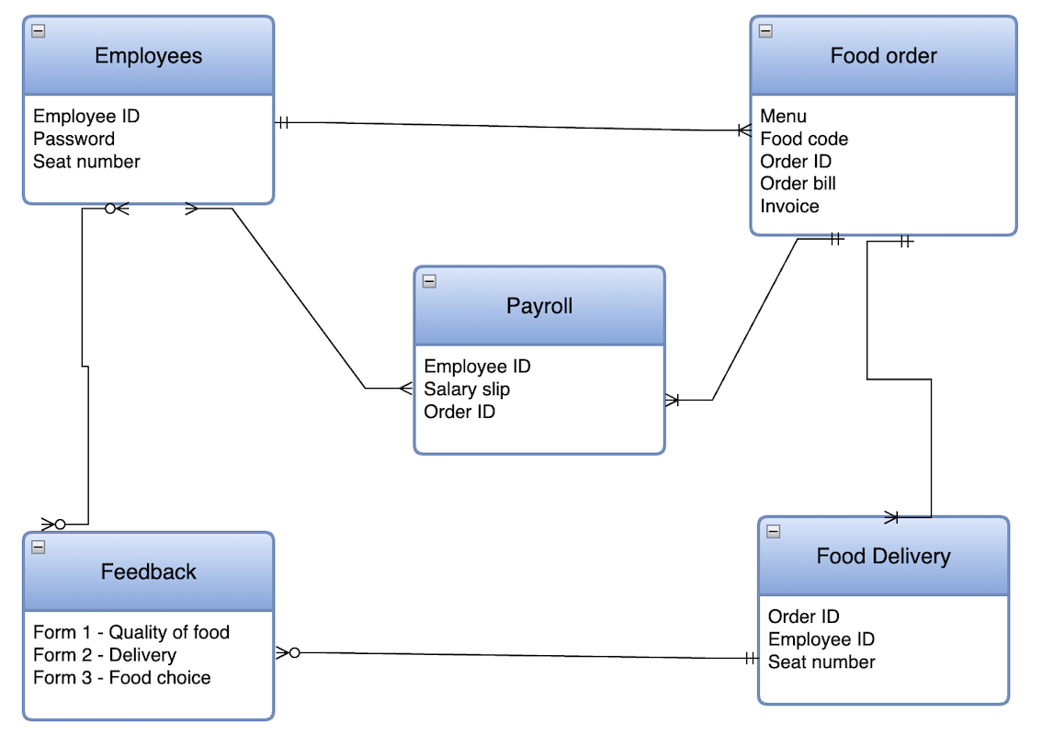

# **Task 10: The Business requirements, both the Functional and Non-Functional**

### Functional requirements :

* The canteen ordering system login page should be accessible to all employees.
* From an administrator's login page, Canteen Manager needs to keep the menu updated every day.
* Orders for lunch must be sent before 11 o'clock every day.
* Employees will have preferred food to order.
* Users will not be able to cancel or change existing orders once a lunch order has been placed.
* Once the order has been delivered to the workstation, the delivery boy must mark it as completed.
* Depending on the quality and taste of the food served by the Canteen, users are free to submit their own comments or feedback.
* The payroll team will be able to determine the order amount for each month so that adequate deductions are made from salary.
* The following reports generated from the canteen ordering system will be accessible to management.
* Most popular dish.
* Number of employees that are using the system.
* Feedback and complaints regarding the employee's satisfaction.
* The report of sales or revenue per day.
* Order forecasting report will help COS to predict future orderings.

### Non-Functional requirements :

* Scalability and Performance: Scalable up to 1500 workers at a time.
* The performance is based on the skills of the catering manager, the cook and the delivery man.
* Availability: The webpage for the canteen ordering system should be very quick.
* Usability: The concept of a user-friendly and self-explanatory ordering system.
* Maintenance: Software development in the Java language.
* Accuracy: The information from the canteen operator and end user should be used to generate reports in the Canteen Order System.
* Security: The employee must have the login ID and password generated by the end to secure your system.

# **Task 11: Wireframes – Homepage, Food Menu and Feedback Page Screen**

